VDS2526 Project Design Report

Part 1. Metadata
- Version: 1.0
- Students: Student 1: César Lara (2506434), Student 2: Theresa Meier (2502348).
- Group number: group_4
- Dataset: Football

Part 2. Project description

2.1 Description of the project and data
Public accessible European football data (2008 - 2016) is analyzed for the football coach of our football club Borussia Dortmund in order to identify strategic insights for the next football season. The goal is to enable informed and data-driven decisions for player recruitment and match strategy. For this, the analysis is structured around the three phases of a football match: before, during and after with a strategy called “3P-Strategy” (Acronym for Preparation, Performance and Productivity), respectively.

2.2 Exploratory analysis of the data
The purpose of the exploratory analysis is to give an introduction and motivation for the main analysis. Potential or existing shortcomings and strengths of our football club Borussia Dortmund should be identified in order to motivate changes in strategy and in the composition of the team. From the available data, the following Exploratory Data Analysis was useful to provide qualitative focus and motivate the main questions of the project. A few key-data insights are shown below:

- Match File: 50% of games score one single goal, when there is no significant difference between the goals scored by home or visiting teams. In addition, a football season is 38 game days at maximum.

Statistic | stage | home_team_goal | away_team_goal
Count | 25.979 | 25.979 | 25.979
Mean | 18,242773 | 1,544594 | 1,160938
SD | 10,407354 | 1,297158 | 1,14211
Minimum | 1 | 0 | 0
25%-Quantil | 9 | 1 | 0
50%-Quantil | 18 | 1 | 1
75%-Quantil | 27 | 2 | 2
Maximum | 38 | 10 | 9
Table 1: Descriptive statistics on match file of the dataset

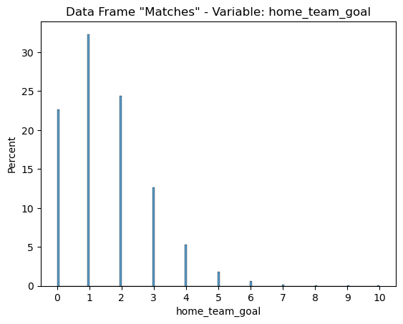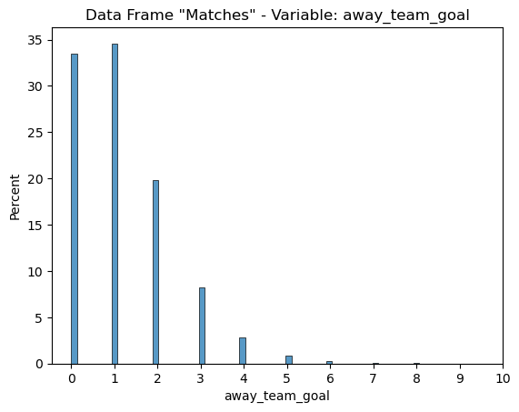
Figure 1: Percentage of different number goals scored from home-team (left side) and away-team (right side)

- Cards File: One quarter of cards that were registered in the dataset were issued before the minute 59.

Statistic | elapsed | elapsed_plus
Count | 62.114 | 3.482
Mean | 56,776572 | 2,629523
SD | 24,073849 | 1,516744
Minimum | 1 | 1
25%-Quantil | 38 | 1
50%-Quantil | 59 | 2
75%-Quantil | 78 | 4
Maximum | 92 | 10
Table 2: Descriptive statistics on cards file of the dataset

- Fouls File: 71% of all fouls are related with actions of serious or disrespect issues (Serious Fouls, unsportsmanlike conduct, verbal abuse).

SubType of Foul | Count | Percentage (in %)
serious_fouls | 7.680 | 40,71
Unsportsmanlike Cond | 3.643 | 19,31
verbal_abuse | 2.003 | 10,62
emergency_brake | 1.313 | 6,96
shirt_pull | 750 | 3,98
stall_time | 642 | 3,40
pushing | 545 | 2,89
hands | 531 | 2,81
advantage | 469 | 2,49
diving | 451 | 2,39
violence | 396 | 2,10
kicked_ball_away | 263 | 1.39
Removing Shirt | 178 | 0,94
Total | 18.864 | 100.00
Table 3: Descriptive statistics on fouls file of the dataset

- Match Possession: There is a consistent cyclical pattern associated with the time that teams possession is taking near minute 30, 45, 70 and 90 minutes elapsed. This would help to consider how the possession evolves during the game.

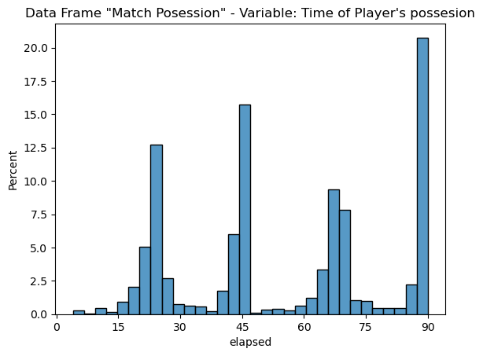
Figure 2: Percentage of possession at different minutes of a match

- Players Attributes: The Overall Player Ranking shows a consistent symmetric shape (not necessarily a normal distribution), with mean 68.6 points and standard deviation of 7.04 points
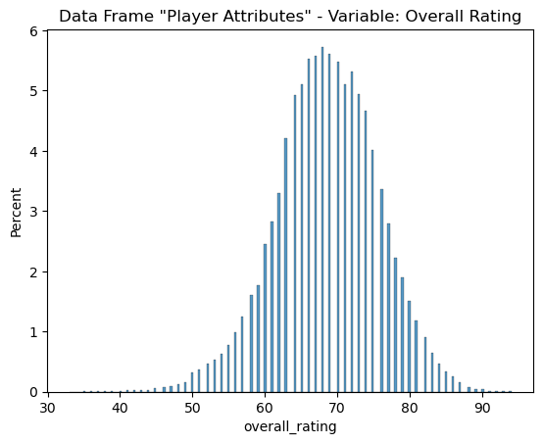
Figure 3: Percentage of overall player rating over all players

2.3 Guiding Questions
The guiding questions are structured around the three phases of a football match: before, during and after

- Pre-match perspective: How well prepared is the other team?
- Mid-match perspective: Which factors increase the chance of winning?
- Post-match perspective: What can we learn from the outcome of our match(es) to improve for the future?

Part 3. Design
The following sections present the design-phase the group went through to arrive at the final design. At first the group turned the guiding question into data processing tasks (Section 3.1) and a storyboard was created (Section 3.2). Then, a diverge-emerge-converge-process was conducted (Section 3.3) before arriving at the final designs (Section 3.4).

3.1 Operationalisation: from questions to tasks

3.1.1 Pre-match
Task 1
- Title: Opponent performance
- Question: How have the other teams and players performed in previous matches and seasons?
- Action: Identify
- Target: Teams and players with a low and high number of valid goals (extremes)
- Objects: Teams and Players
- Measure: Number of valid goals per match
- Groupings: Team and Season / Player and Season

Task 2
- Title: Age structure and Ranking Development
- Question: Do younger players perform / develop better than experienced players?
- Action: Compare
- Target: N/A
- Objects: Player
- Measure: Average Age and Overall Player Ranking (Variable) (Absolute/percentage)
- Groupings: Not Applicable

Task 3
- Title: Misconduct patterns
- Question: Do other teams show patterns of misconducts (cards/fouls)
- Action: Identify
- Target: Teams with low and high number of misconduct (extremes)
- Objects: Teams
- Measure: Number of fouls, yellow cards, red cards
- Groupings: Separate into high-misconducts (i. e. above average) and low-misconduct (i. e. below average) teams

3.1.2 Mid-match
Task 4
- Title: Possession across match outcomes
- Question: Does possession differ between wins, draws, and losses?
- Action: Compare
- Target: N/A
- Objects: Match
- Measure: Possession percentage
- Groupings: Match outcome (wins, draws, losses)

Task 5
- Title: Crossing Frequency
- Question: Which teams rely more (and less) on cross shots?
- Action: Identify and rank
- Target: Dominating teams (extremes)
- Objects: Team
- Measure: Number of cross shots
- Groupings: By team, By Type of Cross and Time of the Game (0-15 min, 15-30, etc.)

Task 6
- Title: Match Involvement of players
- Question: Which players are more active/involved in a game?
- Action: Identify and rank
- Target: Most active players (extremes)
- Objects: Player
- Measure: Number of shots, assists, goals per match
- Groupings: Ranking across matches

3.1.3 Post-match
Task 7
- Title: Differences in the type of match
- Question: Which match characteristics differ between wins, draws, and losses?
- Action: Compare
- Target: N/A
- Objects: Match
- Measure: Average, max and min of goals, possession, shots, fouls, cards
- Groupings: By match outcome (wins, draws, losses)

Task 8
- Title: Top-Goal Scorers
- Question: Which players score the most goals?
- Action: Identify
- Target: Best players (extreme)
- Objects: Player
- Measure: Number of goals (total per season, average per match)
- Groupings: (Average) Goals per player (per season/match)

Task 9
- Title: Card counts per player
- Question: Which players receive the most yellow and red cards?
- Action: Identify and rank
- Target: Dominating players (extremes)
- Objects: Player
- Measure: Number of yellow and red cards
- Groupings: By yellow and red cards

Task 10
- Title: Patterns in fouls
- Question: Are there patterns in fouls that could be prevented or avoided?
- Action: Identify
- Target: N/A
- Objects: Match / Player
- Measure: Number of fouls associated with cards and outcomes of a match
- Groupings: Team, match outcome

3.2 Storyboarding
The storyboard was developed in two stages: 1) each group member thought of a possible initial version of the storyboard; 2) The team met and identified common aspects of the Storyboard and decided the final version

- Stage one: Individual contribution. As detailed in Appendix 1, Group Member 1 suggested a horizontal storyboard using numbering in the sequence of items depicted in the storyboard.

On the other hand, Group Member 2 suggested a vertical storyboard with coloured section notes, starting with a strategic question at the beginning, with development text notes regarding the three moments of the game and finally responding to the question with recommendations.

- Stage two: The merged version was finally achieved, using a story-telling pattern composed of the following components: the opening (blue rectangles) on the left, action (green rectangles) in the middle and resolution (red at the right).

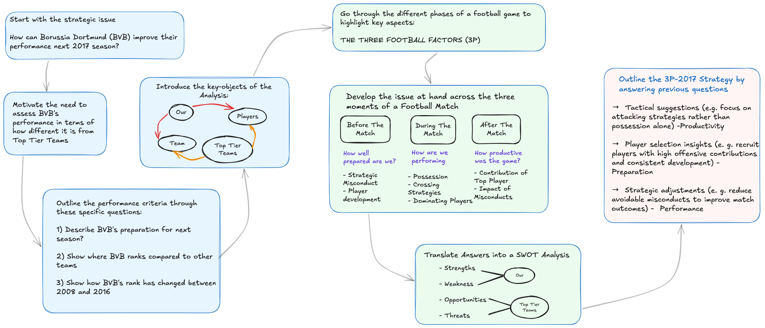
Figure 4: Finale Storyboard. Color coding: blue = opening, green = action, red = resolution

3.3 The design process

3.3.1. Diverge-Phase
In the time between 05.04.2026 and 12.04.2026 the group went through a diverge-phase. The goal was to explore a wide range of design space without evaluating their quality, yet. Each group member individually created multiple sketches with pen & paper. In sum, 18 sketches were created.

The following table gives an overview of the created sketches. The sketches themself can be found in Appendix 2a and 2b.

Unique Identifier | Topic | Description | Type of Plot
CE_T01_V1 | Goal net productivity | Comparing the number of Goals received vs. the number of goals scored by each team | Scatter Plot
CE_T02_V1 | Player performance | Multiple boxplots (by player position) with the Overall Ranking of Player performance | Box-Plot
CE_T03_V1 | Fouls Team Evolution | Number of fouls caused by different teams over different game days | Multiple Line Plots
CE_T04_V1 | Possession of ball over type of Game Result | Density lines associated with the random variable “Percentage of possession per game” across three group of teams | Subplot - Density Lines
CE_T05_V1 | Cross Cross during the Game | Regarding the question if the cross shots has a particular pattern during the game | Heatmap
CE_T06_V1 | Player overall performance | Regarding the task to identify top players | Radial Chart
CE_T07_V1 | Match differences | Regarding the task to compare matches in order to see if there are matches attributes that differ between wins, losses and draw | Box plots
CE_T08_V1 | Players Goal Performance | Regarding the task to identify players who score the most | Ternary Plot
CE_T09_V1 | Patterns in Fouls | Multiple line plots that help to answer the question if fouls observed after the game can be avoided or prevented | Line Charts
CE_T10_V1 | Patterns in Fouls | Using as Players as a group of Egdes and Type of Cards as another Group of Edges, identify which players absorb most of any particular card | Relational Graph
TM_01 | Opponent Performance | Answers the question how other teams have performed in previous matches and seasons | Bar chart
TM_02 | Age Structure and Ranking Development | In regards to the question if younger players perform/develop better than experienced players | Scatter plot
TM_03 | Misconduct Patterns | In regards to the question if teams show patterns of misconducts | Boxplot
TM_04 | Possession vs. outcome | In regards to the question if possession differs between wins, draws and losses | Boxplot
TM_05 | Crossing frequency | In regards to the question which teams rely more (or less) on cross shots | Scatter plot
TM_06 | Match Involvement | In regards to the question which players are more active during the game | Bubble chart
TM_07 | Match Characteristics | In regards to the question which match characteristics differ between wins, draws and losses | Ranking plot
TM_08 | Top goal scorers | In regards to the question which players score the most goals | Bubble chart
Table 4: Overview of sketches from the diverge-phase

3.3.2. Emerge-Phase
In the time between 13.04.2026 and 15.04.2026 the group conducted an emerge-phase. The goal was to identify promising directions and to combine ideas for more refined visualization candidates. The sketches from the diverge-phase were reviewed and grouped based on common themes and patterns. The sketches were then reworked and refined creating a total of six candidates for the final converge-phase.

The following table gives an overview of the created candidates. The sketches themselves can be found in Appendix 3.

Combined Unique Identifiers | Combination based on | Element from first sketch | Element from second sketch | Combination | New Unique Identifier
1. TM_02  2. CE_T02_V1 | - Same Theme  - Both plots show scatters | Scatter Plot (Age vs. Ranking) | - Grouping by player position  - Segmentation by age ranges. | Scatter plot (Age vs. Ranking of Performance), grouping and filtering by position. | CE_TM_01
1. TM_04  2. CE_T04_V1 | - Same Theme  - Differentiation between different match outcomes | Range from boxplots | - Line-plot/ time line  - Comparison with other teams | Line plot/ time line that compares for each match outcome BVB with a chosen comparison team. | CE_TM_02
1. TM_05  2. CE_T05_V1 | - Same Theme  - Comparison of BVB and another team/other teams | Scatter Plot with highlight of BVB and comparison to other teams | Heatmap with crossing intensity across time segments | Scatter plot over a heatmap that shows crossing intensity across time segments. | CE_TM_03
1. TM_07  2. CE_T07_V1 | - Same Theme  - Comparison of different match characteristics differentiated by match outcome | Ranking plot | Boxplot | Ranking plot that shows differences between match outcomes of a season, boxplot with more detailed information that pops-up when cursor hits a point. | CE_TM_04
1. CE_T06_V1 2. CE_T08_V1 | Both show comparison of player performances | Comparison of players | Different attributes for players | Percentile plot that shows how a player compares to other players of the same position for different attributes | CE_TM_05
1. TM-08  2. TM-06 | Same pattern, both are bubble charts | - Goals per season for x-axis  - Minutes played for bubble size | Goal creating action | Bubble chart that shows the contribution to goals in relation to a player’s scoring ability while accounting for their playtime | CE_TM_06
Table 5: Overview of the design process of the emerge-phase

3.3.3 Converge-Phase
In order to select the best sketches, the group decided to identify the best four (4) sketches from the six (6) sketches the group obtained in the emerge-phase. The sketches considered in the converge-phase were redrawn in Excalidraw and are detailed in Appendix 4.

The selection process consisted of grading every assessment criteria for every sketch with a NUF-table. First each group member conducted the assessment individually. The individual scores were then averaged over the number of group members to obtain a final rating. Since it is a qualitative assessment, the group agreed to use a “Likert Scale” with the following features:

- Scale Date Type: Integer
- Range: [1:5]
- Interpretation:
  - 1 = the least desirable value for concept that the column entails
  - 5 = the most desirable value for concept that the column entails
- Assessment criteria:
  - Criteria 1 [New]: Is it a novel or innovative sketches proposal?
  - Criteria 2 [Useful]: Is it a useful sketch that helps answer the project questions?
  - Criteria 3 [Feasible]: Is it possible to build such a graph?
- Rows: Sketches
- Columns: Assessment criteria

The results of the assessment are depicted in the following tables.

Sketch | New | Useful | Feasible | Sum of Points
CE_TM_01 | 3 | 3 | 5 | 11
CE_TM_02 | 4 | 4 | 4 | 12
CE_TM_03 | 5 | 4 | 3 | 12
CE_TM_04 | 4 | 5 | 2 | 11
CE_TM_05 | 4 | 5 | 4 | 13
CE_TM_06 | 5 | 5 | 5 | 15
Table 6: NUF-table of group member 1

Sketch | New | Useful | Feasible | Sum of Points
CE_TM_01 | 2 | 3 | 5 | 10
CE_TM_02 | 3 | 1 | 5 | 9
CE_TM_03 | 3 | 4 | 4 | 12
CE_TM_04 | 4 | 3 | 4 | 11
CE_TM_05 | 5 | 5 | 3 | 13
CE_TM_06 | 5 | 5 | 2 | 12
Table 7: NUF-table of group member 2

Sketch | New | Useful | Feasible | Sum of Average Points
CE_TM_01 | 2,5 | 3 | 5 | 10,5
CE_TM_02 | 3,5 | 2,5 | 4,5 | 10,5
CE_TM_03 | 4 | 4 | 3,5 | 11,5
CE_TM_04 | 4 | 4 | 3 | 11
CE_TM_05 | 4,5 | 5 | 3,5 | 13
CE_TM_06 | 5 | 5 | 3,5 | 13,5
Table 8: Final NUF-table (averaged over all group members)

3.4 The final design
From the NUF-table, the following sketches were selected as the best options for the final design, since they reached the highest scores:

CE_TM_06 | CE_TM_05 | CE_TM_03 | CE_TM_04

For these final sketches, the visual encoding is detailed in the following table.

Sketch | Visual Encoding and Interaction | Importance Description | Idioms
CE_TM_06  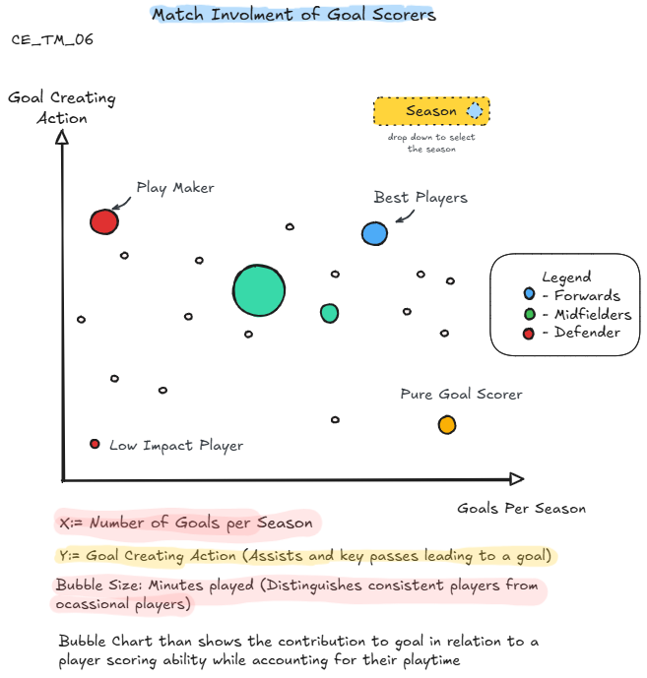 | Expressiveness:  - The size of the bubble gives an ordinal impression of how much involved the player is during the game.  Effectiveness:  - Using two variables that involve goal direct participation and indirect participation effectively reflect the intention of identifying key leading players.  Channels:  - Size: Minutes played  - Color: Player’s Position  - Vertical: Assist productivity  - Horizontal: Goals | Using the player’s position as the color hue brings a positive impression to identify the key players of the game.  Regarding the guiding questions this plot primarily addresses question 3 (post-match perspective) as it concerns the players performances in hindsight | Filtering: Season.  This may help the graph user to compare multiple players during the same season (fairness). Without that, the comparison is not controlled and it would be biased
CE_TM_05  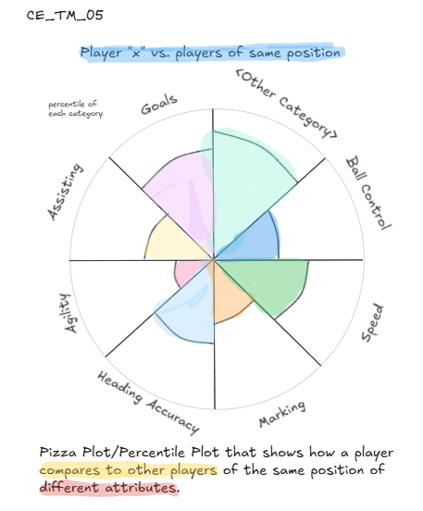 | Expressiveness:  - The bigger the circular sector is (also known as “pizza slice”), the better the player is.  Effectiveness:  - Attributes of the observation item (i.e. player) are compared in common scale (radius length)  Channels:  - Color: Player’s attribute  - Radius: Scale of variable | A player’s performance is compared to the players of the same position. A player is preferred over another player when its area of pizzas’ slices are bigger.  Regarding the guiding questions this plot primarily addresses question 1 (pre-match perspective) as it highlights characteristics of players. | No idioms considered initially.  Nevertheless, potentially use “brushing” to compare two players in the same pizza chart
CE_TM_03  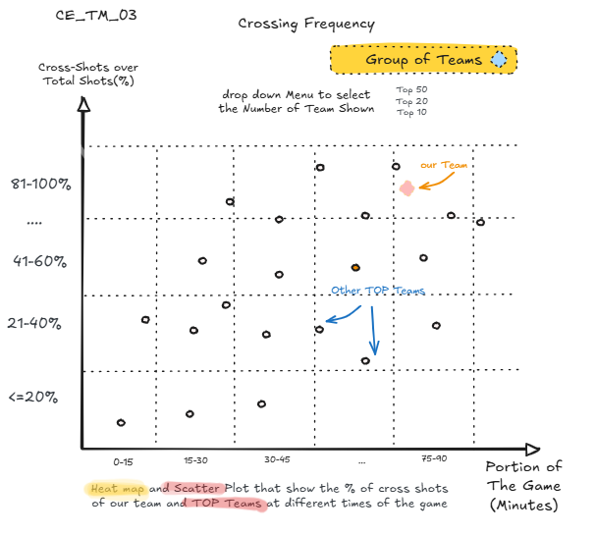 | Expressiveness:  - Since X and Y axis are ordered, the graph user can find the team’s location and compare it to other teams  Effectiveness:  - The graph responds to the question if the variables (game moment and cross Shots) have a relation.  Channels:  - Horizontal: Portion of the game (minutes bins)  - Vertical: Participation of cross shots over total shots (in percentage) | Identifying which portion of the game has less cross shots could be an indication that those teams have more direct action to the goal post (defense strategy is required).  On the contrary, identifying which portion of the game has more cross shots could be an indication that those teams have less direct action to the goal post (Offensive or Counter attack strategy is better for BVB).  Regarding the guiding questions this plot primarily addresses question 2 (during-match perspective) as it concerns actions that happen during the course of a game. | Filtering: Group of Teams.  The idea is to compare our team with significantly better teams (Top Tier) in order to see how different BVB is.
CE_TM_04  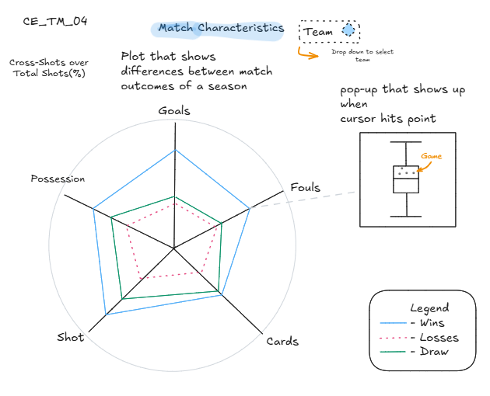 | Expressiveness:  - The advantage of a radial chart is that multiple observations can be compared to the three types of games (wins, losses and draws).  Effectiveness:  - The attributes are equally scaled from 0-100 so they effectively show the differences between games  Channels:  - Color: Distinction between types of games  - Radius: Scale of Attribute | If all variables are scaled in a positive interpretation scale, it would state a solid condition of the team in terms of goals, possession, shot, etc.  If wins and losses have a similar area, the boxplot will help to identify the distribution of the variable for that team during the previous season and see if there is a distinction between wins, losses and draws  Regarding the guiding questions this plot primarily addresses question 3 (post-match perspective) as it concerns different match outcomes. | Filtering: Season.  This will help to assess individual performance of the team.
Table 9: Visual encoding of the final sketches

Part 4. Implementation
In this section, you explain the visualisation implementations that you created to answer the questions. For each visualisation, explain the visual encoding and the interactions. Include screenshots (with annotations if relevant).

Please provide the following for each implemented visual:
- The intended design: a picture (hand drawn or a mock-up) of the design that you would have liked to implement (if you had the help from an experienced programmer).
- How the intended design was modified (or not) following peer feedback.
- The actual design that you were able to implement: a description of the visual encoding of the implemented visual (what does each part refer to; what are the marks and channels). An annotated image/screenshot may be helpful.
- A description of the interactions that are possible.

4.1 Intended designs and modifications
The following table provides an overview of the intended design that we would have liked to implement with the help from an experienced programmer and the modifications we conducted after evaluating the peer feedback. Two of four feedbacks concerned CE_TM_04 (radar chart), one feedback addressed CE_TM_03 and one feedback addressed CE_TM_06. For this reason, modification efforts mainly concerned these designs.

Intended Design | Modification after peer feedback
CE_TM_06   | The feedback concerning this design suggested that bubbles might be overlapping. However, the suggestion covered a standard functioning of plotly (transparent bubbles for better visibility). To address the potential problem, a second drop down menu for teams was added. The second drop down menu allows for the selection of the Top-teams or a specific team. This way, the overlapping of bubbles is reduced.  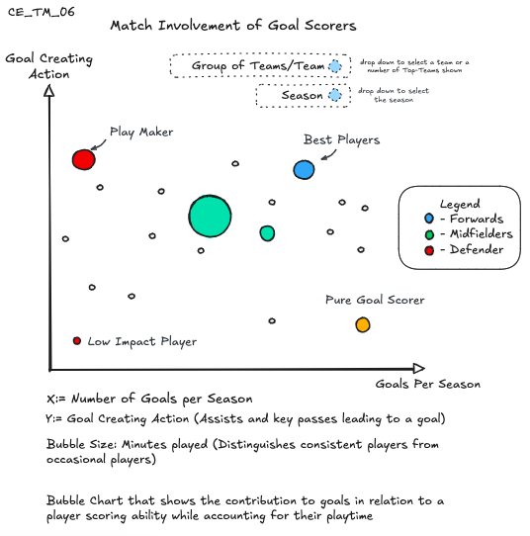
CE_TM_05   | No structural modifications required from peer-review suggestions.
CE_TM_03  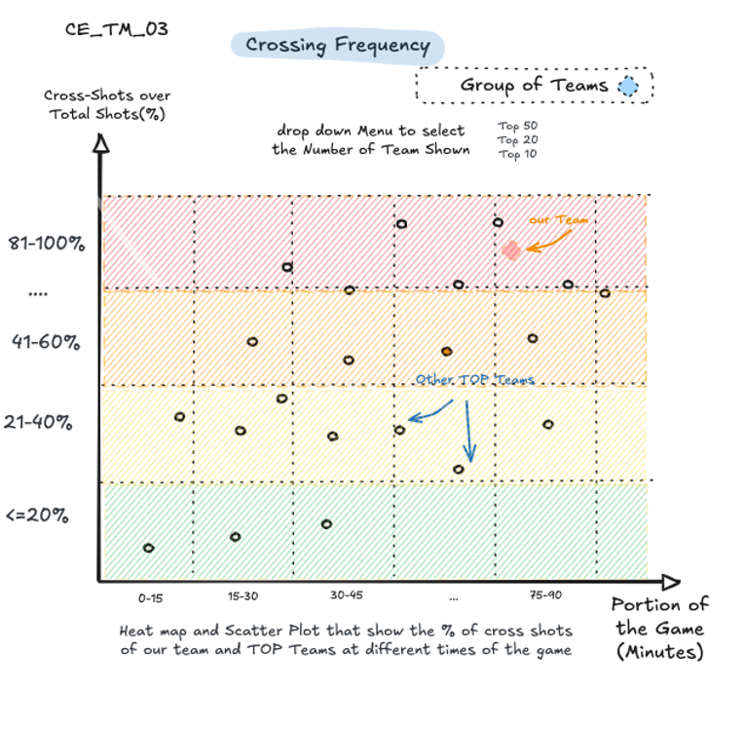 | The feedback concerning this plot raised the question/interest whether crossing frequency is actually related to winning. To make this clearer the graph is split into two graphs. The first graph only shows wins. The second graph shows losses and draws. This way potential patterns become clearer.  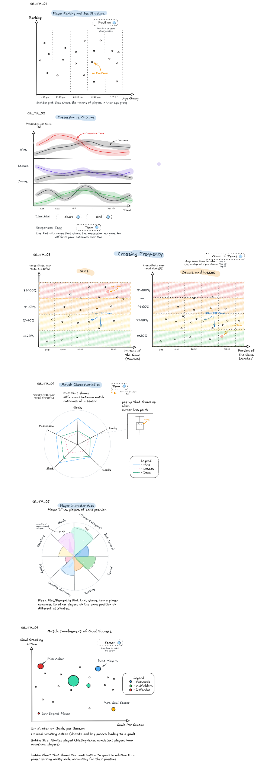
CE_TM_04   | Reviewers stated that this graph was complex to understand. We simplified it using a multiple box plot chart in order to obtain a more strategic view of DB team evolution and how it differs from other teams.  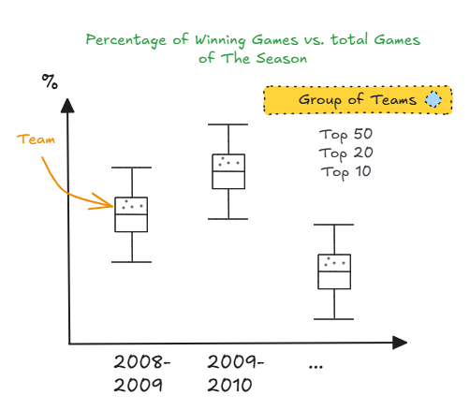

4.2 Actual designs

Implemented Designs | Possible Interactions
CE_TM_06  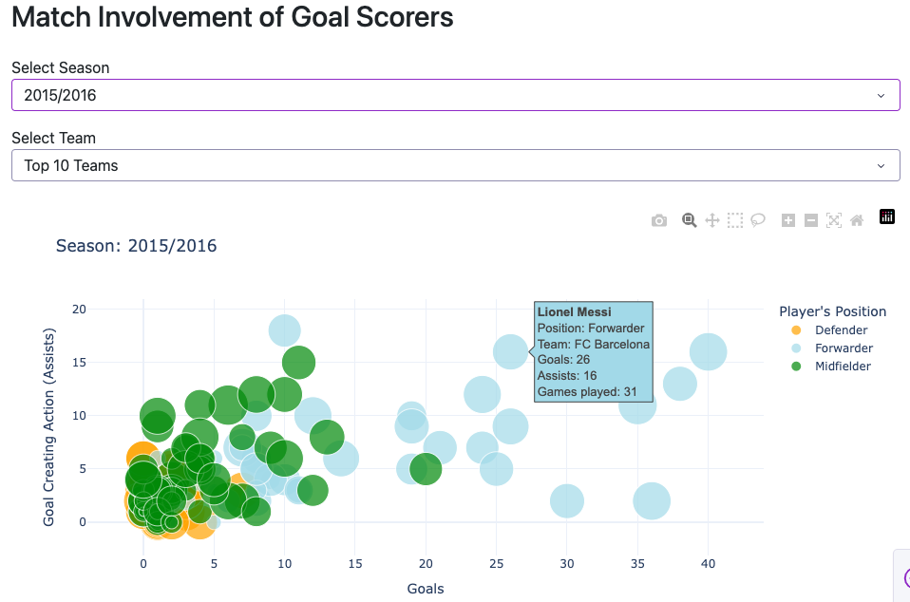 | - In a first drop down menu the user can select the season  - In a second drop down menu the user can select all teams, a number of top teams (Top 100, Top 50, Top 20, Top 15, Top 10) or a specific team  - When hovering over a dot, an information window pops up that shows further information on the player (name, position, team goals per season, goal creating actions (assists), number of games player)
CE_TM_05  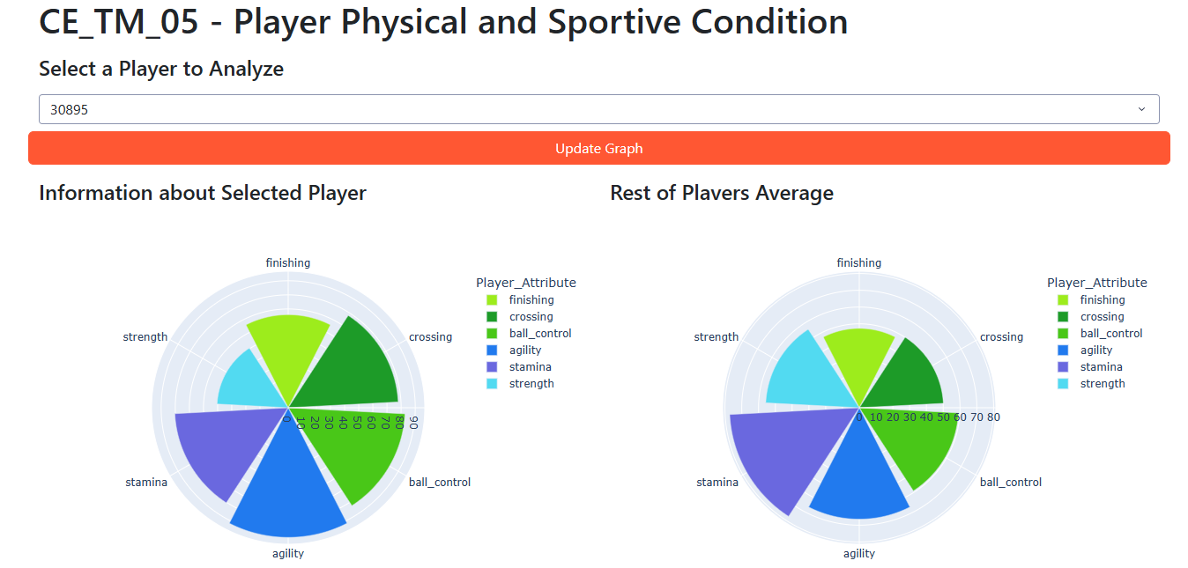 | - The user can select the name of the Player by its “player_api_id” code  - The user can compare the average status of that particular player (Left Pizza) with the average attribute condition of any given player in the league (Right Pizza).  - The Pizza plot uses the size of the circular section (slice of pizza) as a channel to represent the importance of that attribute.  - The blue-shade colors are associated with “physical condition”, while the “green-shaded” pizzas are related with “football performance”.
CE_TM_03  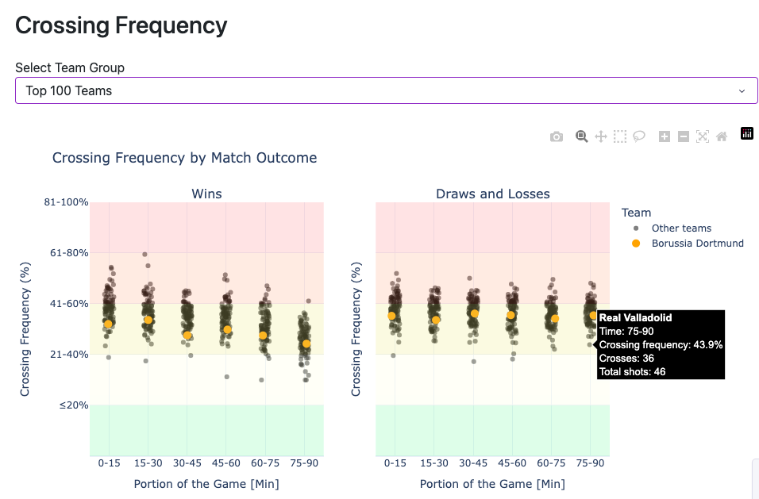 | - In a drop down menu the user can select either all teams or a number of top-teams (Top 100, Top 50, Top 20, Top 15, Top 10)  - When hovering over a dot, an information window pops up that shows further information on the team (team name, portion of the game the dot is addressing, crossing frequency (%), crosses, total shots)
CE_TM_04  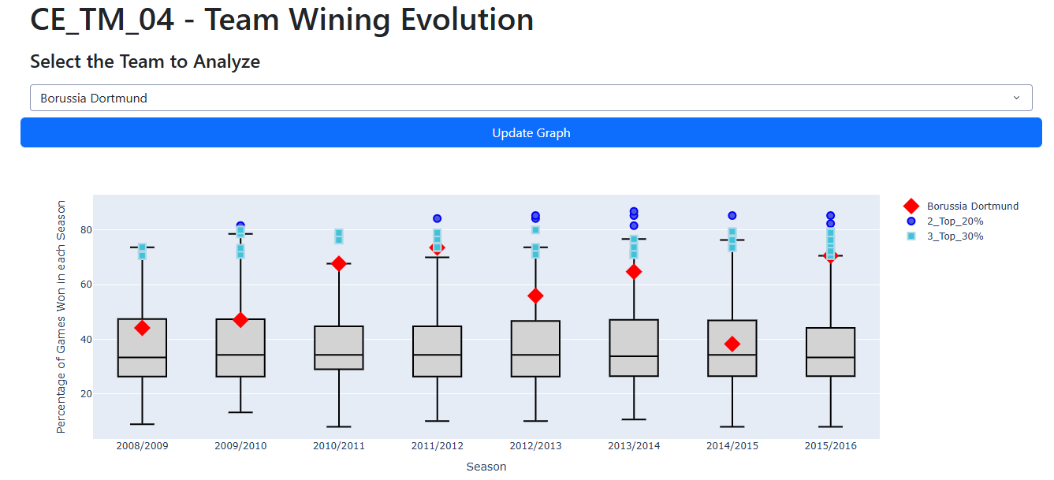 | - The user can select the name of the team from a DropDown list.  - Since this project is to inform the General Manager of the Borussia Dortmund (BVB), it can be seen which seasons improved their performance and when it declined.  - Using the channel of color and diamond as a mark, the user can differentiate how bad or how good was the team’s performance in different seasons.

4.3 Links to code for visualisations

Code for visualisations:

Instructions to reproduce visualisations:

Youtube-Video:

https://youtu.be/kbHiJI1AKeI

If first link is not working: youtube.com/watch?v=kbHiJI1AKeI&feature=youtu.be

In addition, please provide:

- A link to the code for the visualisations (e.g. the github repository). Make sure you include instructions to reproduce your visualisations.
- A link to a 3-5 minute youtube video in which you answer the chosen questions by demonstrating the functionality of the visualisations you created. Try to use the data storytelling techniques we saw in class.
Note: Paste the full URL as links sometimes don’t work. For instructions on how to upload a video, see e.g. https://www.youtube.com/watch?v=VtF2AgFSLAw. Important: set visibility to either "public" or "unlisted" (not "private").

Appendix 1

Individual Storyboards

Proposal Group Member 1
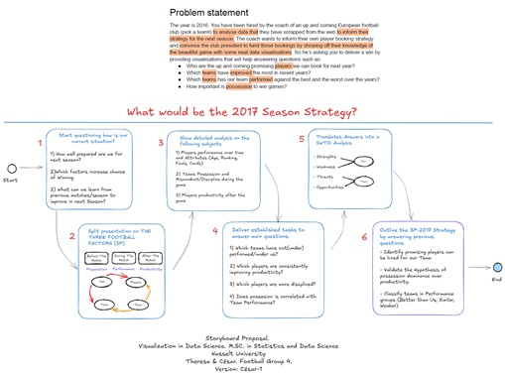
Proposal Group Member 2
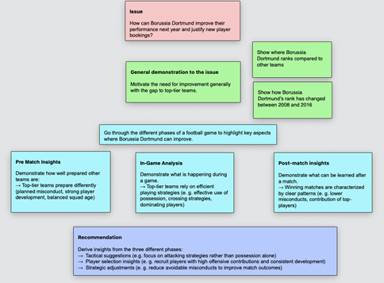

Appendix 2a

Diverge-Phase: Sketches from group member 1

CE_T01_V1 CE_T02_V1 CE_T03_V1 CE_T04_V1 CE_T05_V1
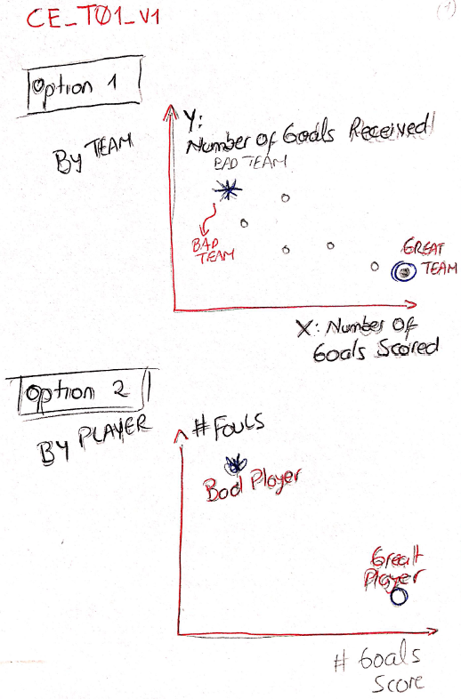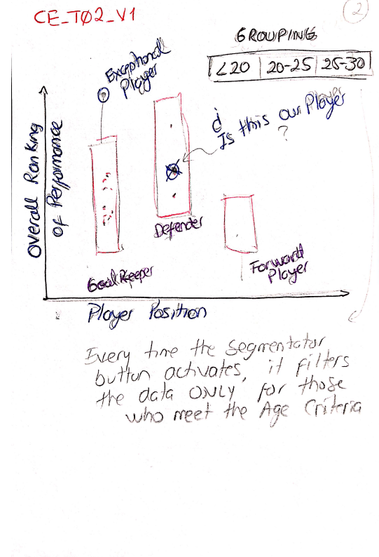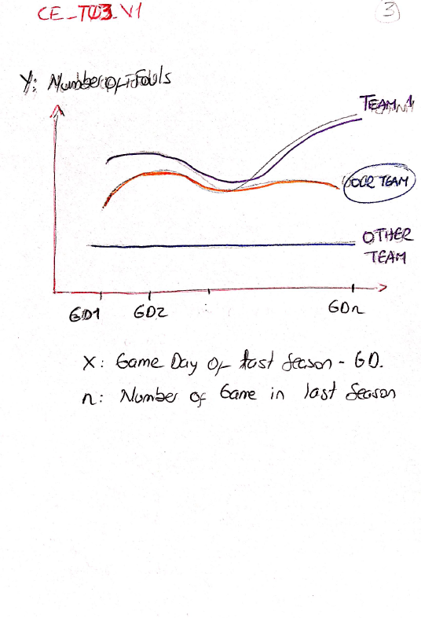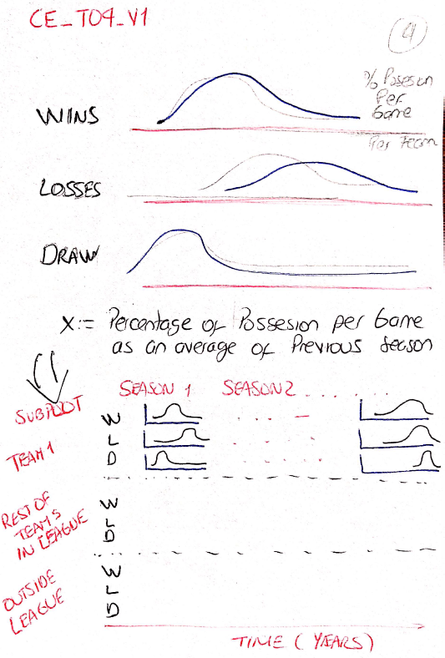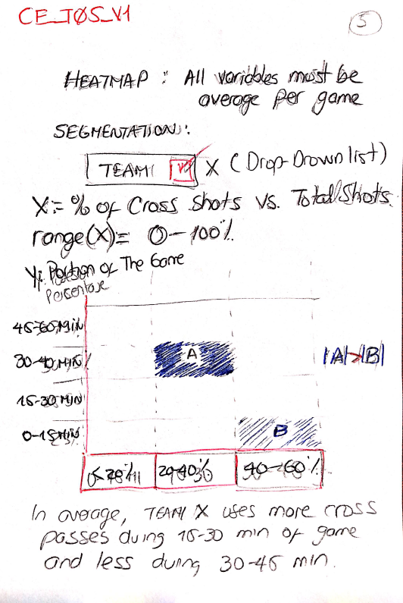

CE_T06_V1 CE_T07_V1 CE_T08_V1 CE_T09_V1 CE_T10_V1
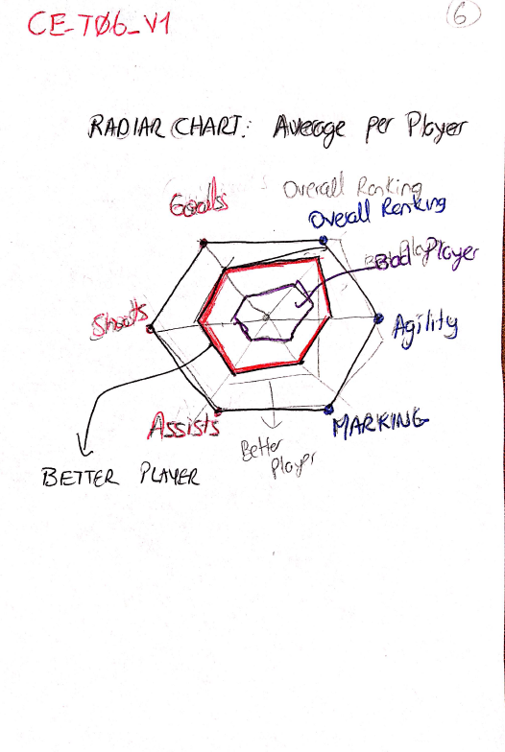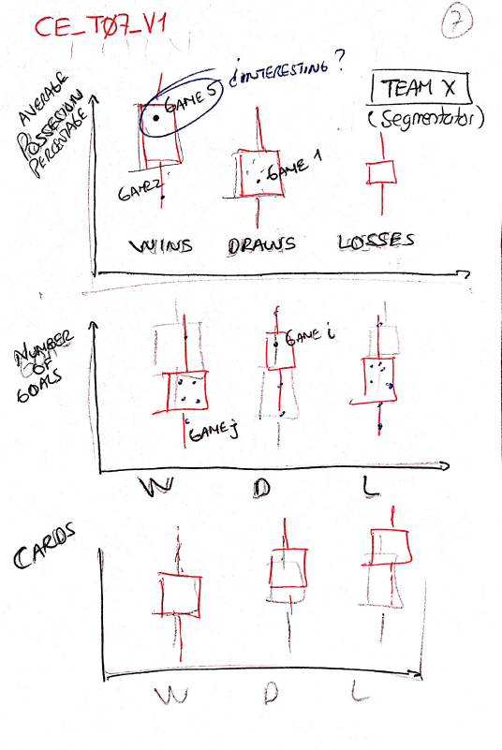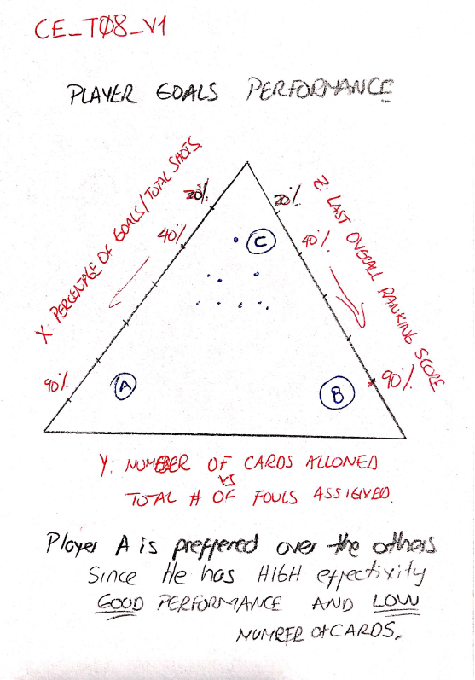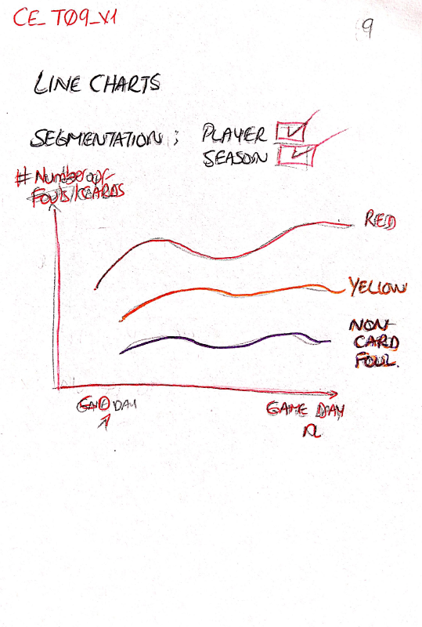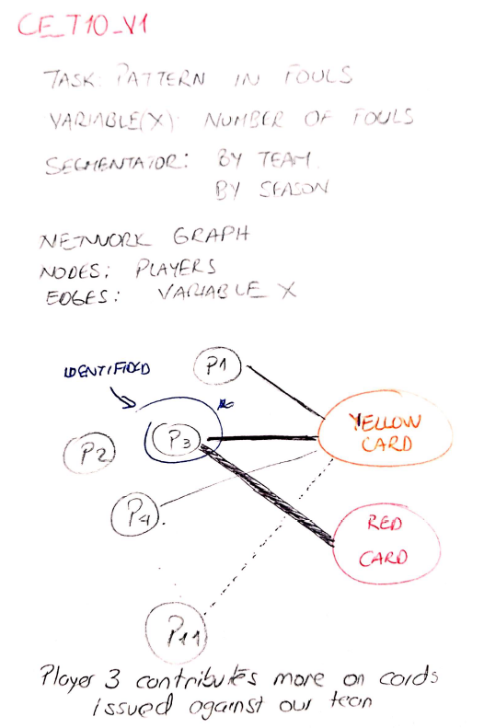

Appendix 2b

Diverge-Phase: Sketches from group member 2

TM_01 TM_02 TM_03 TM_04
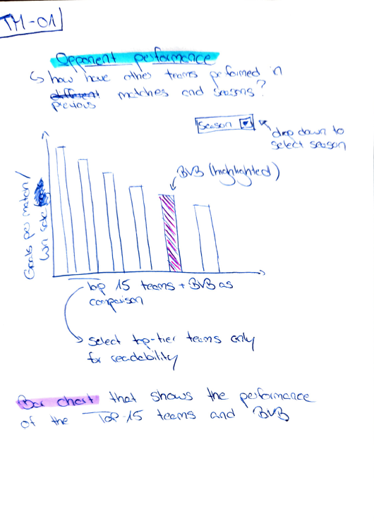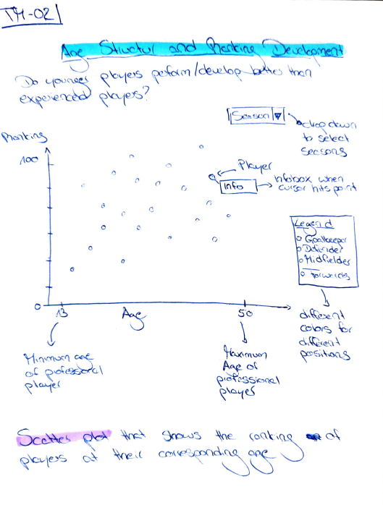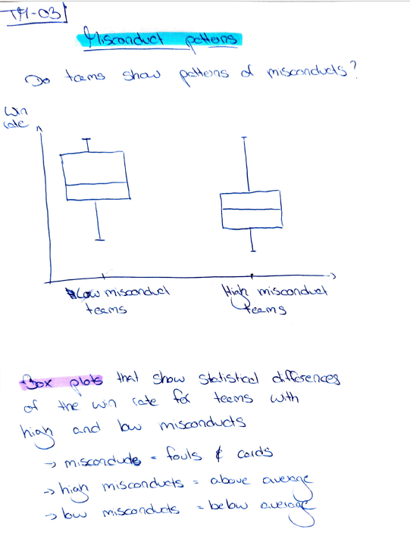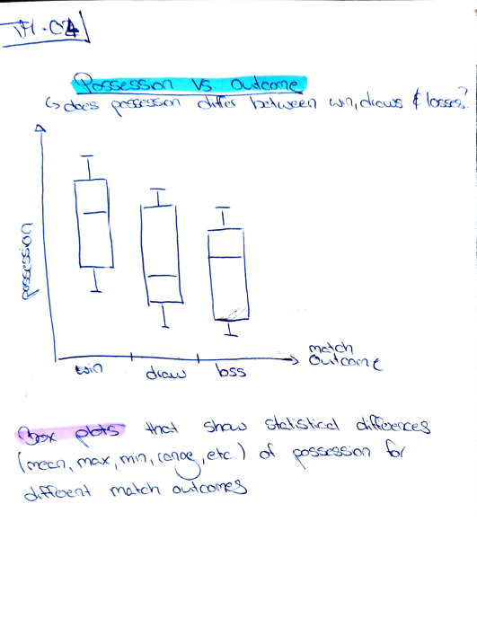

TM_05 TM_06 TM_07 TM_08
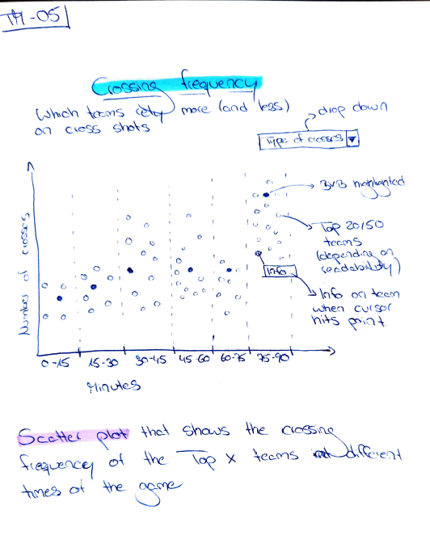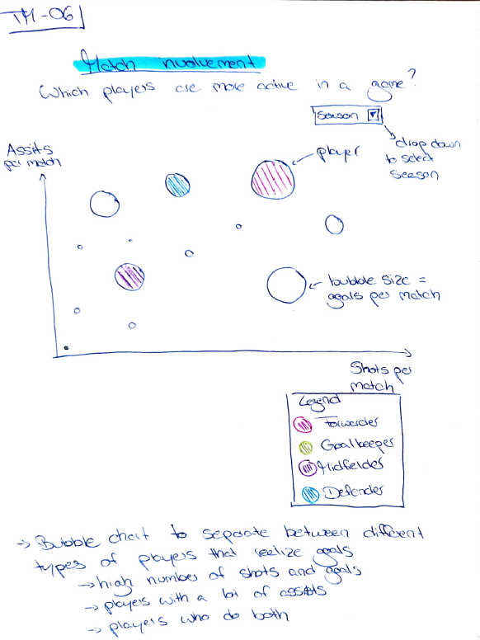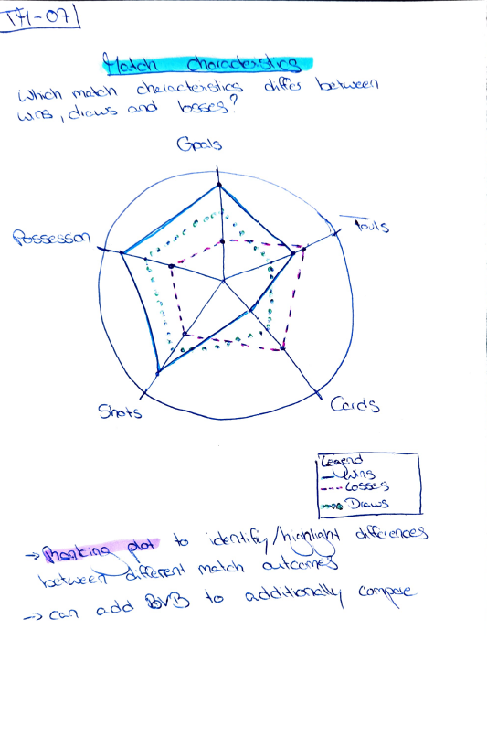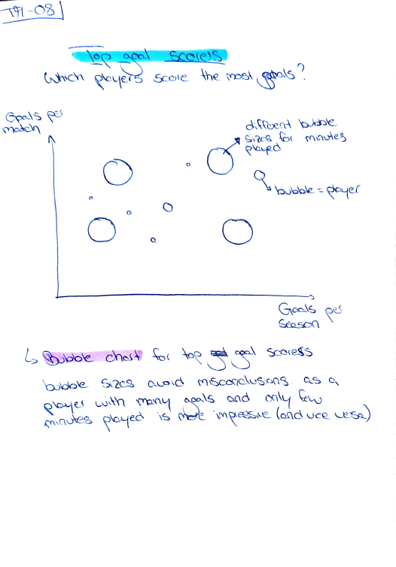

Appendix 3

Emerge-Phase: Reworked and refined sketches from the diverge-phase
Convention:

Group member 1
Group member 2
Merged Version:

Reworked Sketch No.1. CE_TM_01  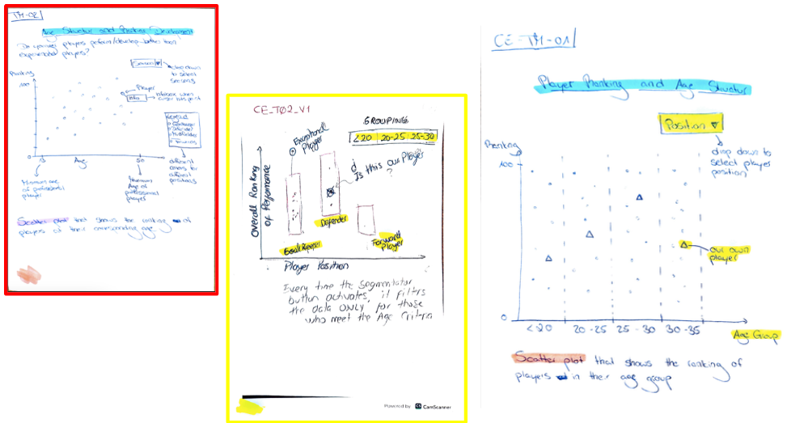  Reworked Sketch No.3. CE_TM_03  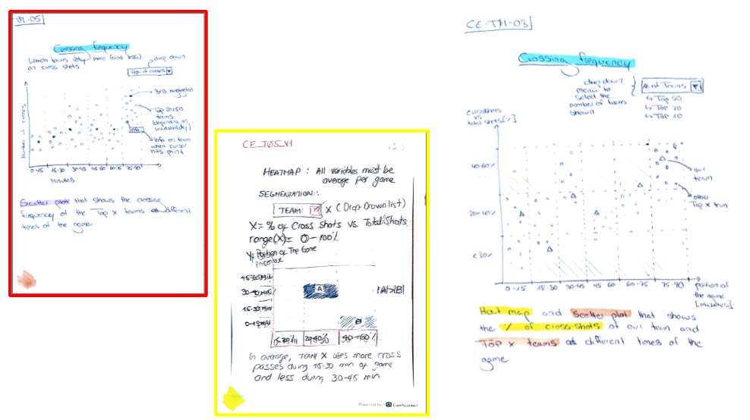  Reworked Sketch No.5. CE_TM_05  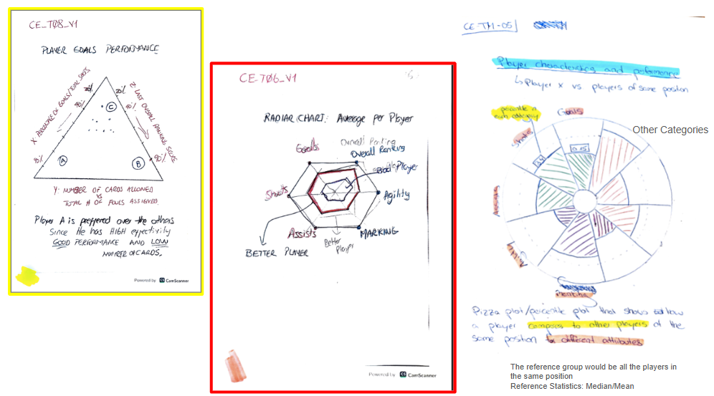 | Reworked Sketch No.2. CE_TM_02  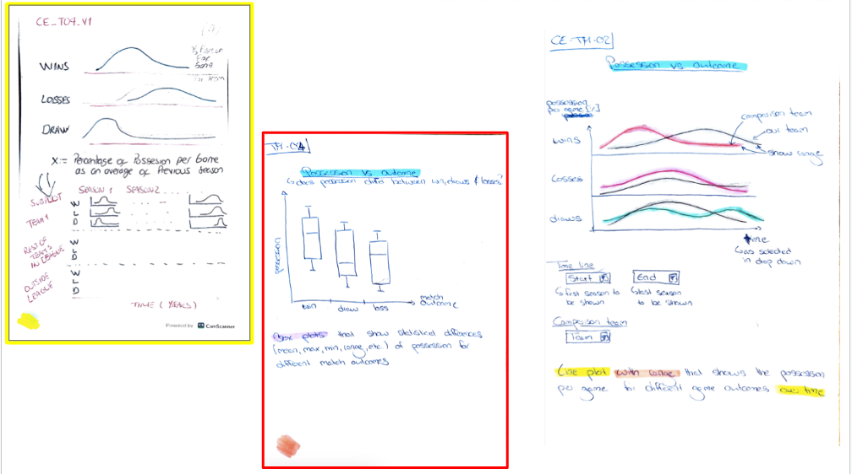  Reworked Sketch No.4 . CE_TM_04  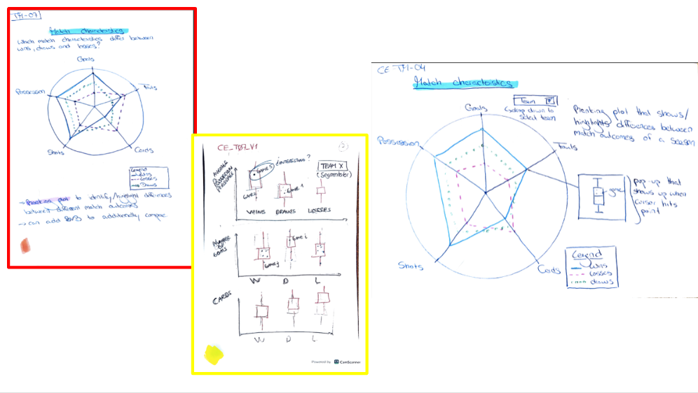  Reworked Sketch No.6. CE_TM_06  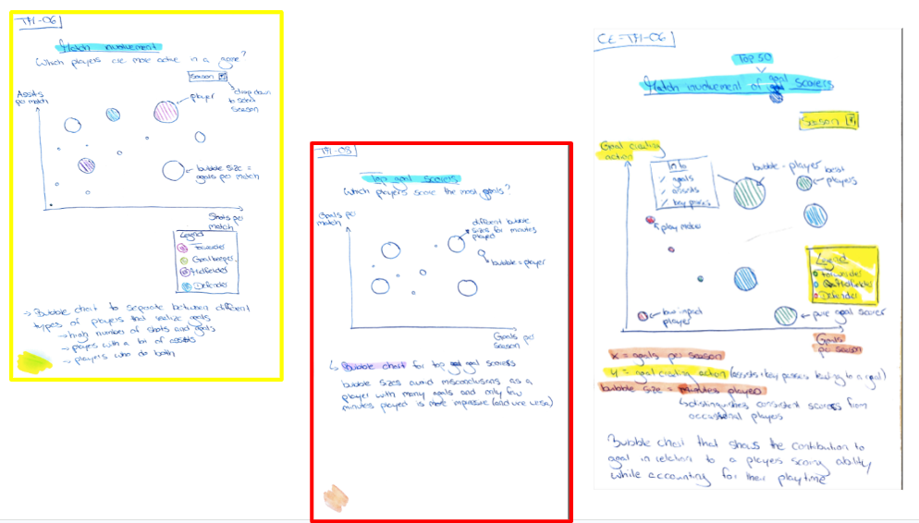

Appendix 4

Converge-Phase: Refined Sketches

Items marked with a yellow star at the top right of the square are the selected ones.





